Israel’s Operation
Swords of Iron Update
October 18, 2023

Ari Cicurel
Assistant Director of Foreign Policy

Yoni Tobin
Policy Analyst

Zachary Schildcrout
Policy Analyst

Anna Schaftel
Programs and Outreach Associate

On October 7, Hamas launched an unprovoked and unprecedented multi-pronged attack on Israel by land, air, and sea. JINSA issued a NatSec Brief with an early assessment of the war on October 8 and has produced daily updates during the war. Yesterday, JINSA also held a webinar with JINSA’s Director of Foreign Policy Jonathan Ruhe, JINSA Counselor and Former Under Secretary of Defense for Policy Ambassador Eric Edelman, and Former Commander of U.S. European Command & Former Supreme Allied Commander Europe of NATO Allied Command Operations General Philip M. Breedlove, USAF (ret.). Updated information and analysis are below, which JINSA will continue to produce throughout the war.

Last 24 Hours
Attacks Against Israel
- Roughly 6,930 rockets, mortars, drones, and other projectiles have been fired from Gaza during the war.
  - Rockets struck a house in Sderot and an undisclosed location in the Tel Aviv suburb of Yavne on October 17, causing no injuries. Sirens sounded in Tel Aviv, Jerusalem, Ashkelon, Ashdod, Kissufim, Amioz, Beit Hillel, Ein HaShlosha, Holon, Kiryat Shemona, Kissufim, Miftahim, Nir Oz, Petah Tikva, Rishon LeZion, Be’er Sheva, and Yesha, as well as other locations in southern Israel.
  - A barrage of rockets struck Sderot on October 17, with seven direct hits reported. Two people were lightly injured.
- At least seven rockets, mortars, drones, and other projectiles have been fired from Lebanon in the last 24 hours.
  - On October 18, an undisclosed number of anti-tank missiles were fired at IDF positions near the town of Shtula along the Lebanese-Israeli border. Hezbollah later took responsibility for the attack.
  - On October 18, two missiles were fired from southern Lebanon at Israel. One was intercepted and details about the other were not available.
  - On October 17, Hezbollah launched six anti-tank guided missiles at a number of Israeli towns and military posts along the Lebanese-Israeli border, wounding three people.
  - An additional two rockets and drones were launched at northern Israel from Lebanon on October 17.
  - On October 17, Israel’s Iron Dome intercepted a drone approaching Israeli airspace from Lebanon.
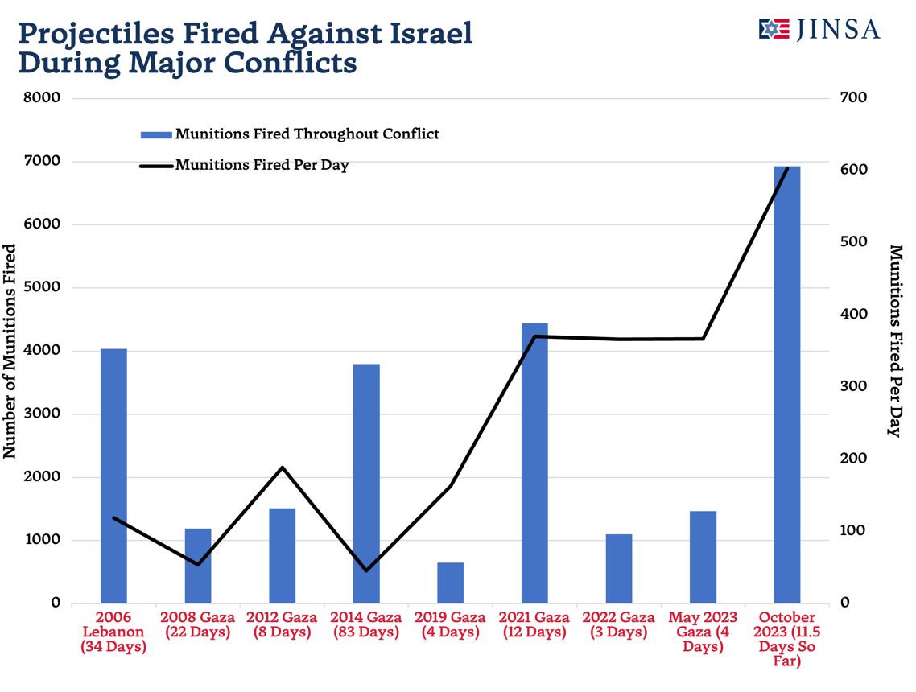

IDF Operations
- During an October 16 JINSA webinar with IDF Major General (ret.) Yaacov Ayish, IDF Major General (ret.) Yaakov Amidror, IDF Major General (ret.) Amikam Norkin, and JINSA Vice President for Policy Blaise Misztal, Norkin noted, “we dropped in the first week almost 6,000 bombs… many of the Hamas commanders have already been attacked while we are defending the state of Israel with the Iron Dome.”
  - Norkin further noted that this figure was “more than the American forces dropped in Afghanistan” in some years.
- The IDF stated that it launched strikes against over 200 Hamas and Palestinian Islamic Jihad targets in Gaza in the last 24 hours.
  - These targets included the house of the family of Hamas leader Ismail Haniyeh, who lives in Qatar, reportedly killing 14 people, including Haniyeh’s brother and nephew.
  - The IDF also killed Ayman Nofal, commander of Hamas’s Central Gaza Brigade.
  - The IDF said that its fighter jets struck operational command centers, military infrastructure with operatives within, and hideouts belonging to Hamas in Saytun, Jabalya, Rafah, and Khan Younis.
- The IDF responded to rocket and anti-tank fire from Lebanon by striking targets in southern Lebanon.
  - On October 18, the IDF responded with artillery fire to a Hezbollah anti-tank missile attack near Shtula along the Lebanese-Israeli border.
  - On October 17, the IDF announced that it struck additional Hezbollah targets in southern Lebanon, including an observation post and military infrastructure targets.
  - The IDF announced on October 17 that it had struck several Hezbollah targets in southern Lebanon in response to six anti-tank guided missile attacks on northern Israeli towns and military outposts that were launched by Hezbollah.
- Israeli press reported on October 18 that Israel, in a joint operation involving both the IDF and the Shin Bet, had arrested forty-one terrorists in the West Bank, including thirty Hamas operatives.
- Israeli Attorney General Gali Baharav-Miara and Communications Minister Shlomo Karhi reached an agreement on October 17 to ban Al Jazeera from being broadcasted in Israel due to security risks.
  - Karhi stated that Al Jazeera broadcasts the locations of IDF troops outside of Gaza, exposing them to attack, and incites violence against Israel through propaganda.

Casualties and Hostages
- Approximately 1,400 people in Israel have died and nearly 4,500 have been injured in the war.
  - 306 Israeli soldiers have been killed.
  - Numerous foreign nationals have been killed in the war, including at least thirty-one American nationals, twenty-four Thai nationals, twenty-one French nationals, seventeen British nationals, ten Nepalese nationals, seven Argentinian nationals, sixteen Russian nationals, four Romanian nationals, four Chinese nationals, three Brazilian nationals, three Belarusian nationals, three Chilean nationals, three Philippines nationals, two Ukrainian nationals, two Peruvian nationals, five Canadian nationals, a Cambodian national, a Colombian national, an Irish national, an Italian national, a Spanish national, a Swiss national, a Turkish national, and an Austrian national.
- According to the Palestinian Ministry of Health, approximately 3,000 people have been killed in Gaza and 12,500 have been injured during the war.
- According to the Palestinian Ministry of Health, sixty-two people have been killed and an additional 1,250 have been wounded in the West Bank.
- The IDF claims at least 1,500 infiltrators from Gaza have been killed in Israel since the start of the war.
- According to the IDF’s latest press release, the families of 199 individuals have been notified that their loved ones were taken hostage.
- Foreign nationals also remain missing, including at least thirteen American nationals, fifteen French nationals, fifteen Argentinian nationals, nine Ukrainian nationals, eight Russian nationals, three Canadian nationals, three Philippines nationals, two Austrian nationals, three Italian nationals, two Paraguayan nationals, five Peruvian nationals, two Sri Lankan nationals, two Tanzanian nationals, a Chilean national, an Azeri national, and a Nepalese national.
  - At least eight German nationals, seventeen Thai nationals, four Portuguese nationals, two Italian nationals, and two Mexican nationals have been taken hostage by Hamas.
- According to the IDF, a rocket fired at Israel by Palestinian Islamic Jihad (PIJ) on October 17 misfired and struck al-Ahli hospital in Gaza, reportedly killing hundreds, though the Palestinian Health Ministry originally blamed Israel.
  - The IDF released a photo of its radar array showing that the rocket was one of ten rockets that were fired from Gaza City, as well as audio from internal Hamas communications stating that the rocket was fired by PIJ.
    - The audio included Hamas operatives’ statements that the “shrapnel missile is local shrapnel and not like Israel shrapnel” and that “they shot it from the cemetery behind the hospital.”
- IDF spokesman Daniel Hagari held a conference in which he said that Israel had conducted a full investigation, and that it had several indisputable pieces of evidence absolving it of responsibility.
  - Hagari stated that the IDF radar tracked the rockets and that trajectory analysis confirmed the rockets originated from Gaza, and that there was no air-to-surface munition crater visible in photos of the incident, as there would have been had Israel conducted an airstrike.
  - Hagari also noted that 450 rockets fired by terrorist groups in the Gaza Strip have misfired and landed in the Gaza Strip since the war began, including the one which caused the tragic incident at al-Ahli hospital.
- President Biden stated on October 18 that “I was deeply saddened and outraged by the explosion at the hospital in Gaza yesterday. And based on what I’ve seen, it appears as though it was done by the other team, not [Israel].”
- Video footage from Israel’s Channel 12 that showed a rocket barrage originating next to the al-Ahli Hospital when it was bombed, indicating that these rockets emanating from Gaza were likely what struck the hospital.
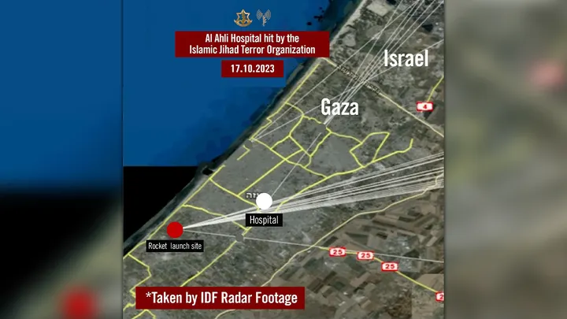
Source: Israeli Foreign Ministry
- Mass protests broke out worldwide in response to the October 17 hospital explosion, blaming Israel for the incident.
  - Over 100 protestors gathered outside the U.S. embassy in Beirut late October 17 and eventually began rioting. The protestors threw large rocks and Molotov cocktails, and authorities had to use tear gas and water cannons to disperse the rioters.
  - Afterward, the U.S. State Department issued a Level 4 Travel Advisory warning U.S. citizens not to visit Lebanon and allowing the family of diplomats and some non-essential personnel to voluntarily leave the country.
  - In the West Bank, protestors in Ramallah and Tubas clashed with Palestinian security forces late October 17. Explosions were heard and a number of protestors threw rocks at police vehicles.
  - In Istanbul, late October 17, protestors rioted and attempted unsuccessfully to storm the Israeli consulate; over sixty people were injured, mostly Turkish police officers, and five people were arrested.
  - In Amman, late October 17, protestors rioted and attempted unsuccessfully to storm the Israeli embassy.
  - In Tunis, thousands of pro-Palestinian protestors assembled outside both the French embassy and the U.S. embassy on October 18.
- Since the war began, there has been an increase in antisemitic attacks and terrorist threats.
  - Early in the morning of October 18, a synagogue in Berlin, Kahal Adass Jisroel, was firebombed. No injuries were reported.
  - On October 18, a Jewish day school in Rome was evacuated following a bomb threat.
  - On October 18, six airports in France were forced to evacuate following bomb threat warnings. The evacuations came as France is on high alert following a stabbing attack in Arras last week.
    - The Palace of Versailles, one of France's most popular tourist attractions, was evacuated for the third time this week due to security concerns.
  - On October 14, FBI Director Chris Wray said the United States had seen a spike in domestic terror threats in connection to the Israel-Hamas War: “In this heightened environment, there’s no question we’re seeing an increase in reported threats, and we have to be on the lookout, especially for lone actors who may take inspiration from recent events to commit violence of their own.”

Iranian Involvement
- On October 18, Iranian Foreign Minister Hossein Amir-Abdollahian called for all members of the Organization of Islamic Cooperation (OIC) to impose a series of measures against Israel, including an oil embargo, expulsion of Israeli ambassadors, and other sanctions.
  - The OIC, which includes Iran and fifty-six other countries, is holding an emergency meeting in Jeddah, Saudi Arabia, on October 18 to discuss the ongoing war.
- Hezbollah called for October 18 to be a global “day of rage against the enemy” in response to the al-Ahli hospital explosion, which it blamed on Israel and referred to as a “brutal crime” and a “massacre.”
- Reuters reported that U.S. forces stationed at al-Asad base in Iraq came under attack on October 18 by two combat drones, both of which were intercepted. If the attack was conducted by Iran-backed groups, it would be the first such attack by Iranian proxies against U.S. forces since an escalation in March.

U.S. and International Response
- On October 18, President Biden visited Israel and met with its new war cabinet. Before the meeting, he said at a press conference with Prime Minister Netanyahu that “the United States stands with you in defense of that freedom, in pursuit of that justice, and in support of that peace, today, tomorrow, and always, we promise you” and that it “will continue to have your back.”
  - Netanyahu said that Biden’s visit, the first ever by a U.S. president to Israel in wartime, is “deeply, deeply moving” and “speaks to the depth of your personal commitment to Israel. It speaks to the depth of your personal commitment to the future of the Jewish people and the one and only Jewish state.” Netanyahu added that “for the people of Israel, there’s only one thing better than having a true friend like you standing with Israel, and that is having you standing in Israel.”
  - From the United States, the meeting also included Secretary of State Antony Blinken, National Security Adviser Jake Sullivan, Middle East envoy Brett McGurk, and chargé d’affaires Stephanie Hallett. Israeli participants included Defense Minister Yoav Gallant, war cabinet minister Benny Gantz, Strategic Affairs Minister Ron Dermer, war cabinet observer and former IDF Chief of Staff Gadi Eisenkot, MK Aryeh Deri, National Security Adviser Tzachi Hanegbi, Netanyahu Chief of Staff Tzachi Braverman, Military Secretary Avi Gil, and Ambassador to the U.S. Michael Herzog.
- The Senate Foreign Relations Committee is holding a hearing on October 18 on the nomination of Jacob Lew to be the U.S. ambassador to Israel.
  - The United States has not had a confirmed ambassador to Israel since July, when Ambassador Thomas Nides left the post.
- On October 18, Egyptian President el-Sissi stated that the Rafah crossing, the sole passageway between Egypt and Gaza, remained closed to aid convoys. El-Sissi blamed that reality on “repeated bombings by Israel of the Palestinian side of the crossing [which] have prevented its operation.”
  - German Chancellor Olaf Scholz, who is in the Middle East this week, stated that Germany is working with Egypt to “get humanitarian access to the Gaza Strip as quickly as possible.”
    - Scholz also warned Iran and Hezbollah “not to intervene in this conflict.”
- On October 17, Palestinian Authority President Mahmoud Abbas canceled his planned appearance for an October 18 meeting with U.S. President Joe Biden, Jordan’s King Abdullah II, and Egyptian President Abdel Fattah el-Sissi due to Israel’s purported airstrike on the Al-Ahli hospital. Later that day, the Jordanian Ministry of Foreign Affairs announced the cancellation of the summit.
- On October 17, The Times of Israel reported that Russia and the United Arab Emirates called for an emergency meeting of the UN Security Council to discuss the conflict following the explosion at the Al Ahli hospital.
  - Several countries, including Saudi Arabia, Bahrain, Egypt, Jordan, and Turkey, blamed Israel for the explosion.
    - Jordanian King Abdullah II stated that Israel had perpetrated a “massacre” and “war crime.”

Analysis
- Considering the evidence that the IDF produced about the rockets that struck the al-Ahli Hospital originating in Gaza, the Hamas-run Palestinian Health Ministry’s claims about the bombing appear to be an example of information warfare, in which Israel’s enemies intentionally distort or misrepresent civilian casualties as being the direct result of Israeli war crimes to turn international public opinion against Israel’s self-defense efforts.
  - The tragedy also highlights the extent to which Palestinian terrorist groups’ projectiles threaten the lives not only of Israelis but also Palestinian citizens living in Gaza.
    - As JINSA has previously noted, in the 2021 Gaza War, approximately 900 Hamas and PIJ rockets, or roughly one-seventh of all rockets launched from Gaza during the conflict, misfired and landed inside Gaza.
    - These misfires caused the deaths of at least twenty Palestinian civilians and injured hundreds.
- Widespread protests that escalate to riots or violence in the West Bank could cause Israel to devote additional resources there instead of Gaza or its northern border. Similarly, Israeli and American civilians in locations abroad remain at risk from terrorism.
- If conducted by Iran-backed groups, the October 18 drone attack against the al-Asad base in Iraq would indicate the waning of U.S. deterrence since President Biden ordered airstrikes in March against Iranian proxies that had targeted U.S. service members in Syria.
- On October 17, JINSA hosted a webinar with Amb. Eric Edelman (Counselor at JINSA's Gemunder Center for Defense & Strategy), Gen. (ret.) Philip M. Breedlove (former NATO Supreme Allied Commander), and JINSA Director of Foreign Policy Jonathan Ruhe on the global implications of the Israel-Hamas conflict.
  - Amb. Edelman argued that the United States now faces “the most complex security environment… since the end of World War II and arguably in its history.”
  - Discussing the historical context for current strains in the U.S. defense industrial base, Amb. Edelman noted, “after the Cold War ended… we took a ‘peace dividend’ and cut defense budgets… so the defense industry shrank as a result… so we have fewer companies involved in the defense industry to begin with.”
  - Amb. Edelman also noted that there is no short-term trade off between U.S. efforts to aid Ukraine and its newfound need to aid Israel, saying “let’s be clear: we’re not fighting two wars ourselves right now. We’re supporting our allies… if we had to fight two wars ourselves right now, we’re not in a position to do that.”
    - He added, “what our Israeli colleagues need, which is basically Tamir interceptors for the Iron Dome and small-diameter bombs for precision strikes in Gaza, are not things we’ve been providing to Ukraine.”
  - While discussing how U.S. adversaries view the Israel-Hamas war, both Gen. Breedlove and Amb. Edelman argued that U.S. deterrence depends on a forceful backing of its partners and allies.
    - Gen. Breedlove commented that “Our policy – China-Taiwan; North Korea-South Korea; Israel-Iran;… is being written in Ukraine right now… the world is watching how we respond to unmitigated evil in Ukraine right now, and now we’re seeing unmitigated evil in Israel.”
    - Amb. Edelman reiterated this point, saying that “we have to draw the line here.”
  - Gen. Breedlove also commented that Russia would likely only engage in rhetorical support or limited provisions of weaponry to Iran at most, a sentiment that was echoed by Amb. Edelman, who noted that Russia had to engage in a “balancing act” that would neither overly alienate Iran nor overly agitate the United States and Israel.
  - Regarding China, Amb. Edelman noted that China may try to use the war as part of its information operations to criticize the West. Gen. Breedlove noted that Hamas itself is heavily focused on its own information operations to “change world opinion about Israel” through deception and sowing mayhem in Gaza.
  - On the subject of Saudi normalization, Amb. Edelman stated that normalization talks would likely be indefinitely suspended but that this is not a “permanent condition” and that there would likely be a number of opportunities for such talks to resume in the future.
  - Discussing the U.S. deterrence posture, Amb. Edelman lauded the United States deploying two aircraft carrier strike groups to the region, but cautioned that “deterrence is always… a combination of capability and perception of will by the adversary to use that capability.”

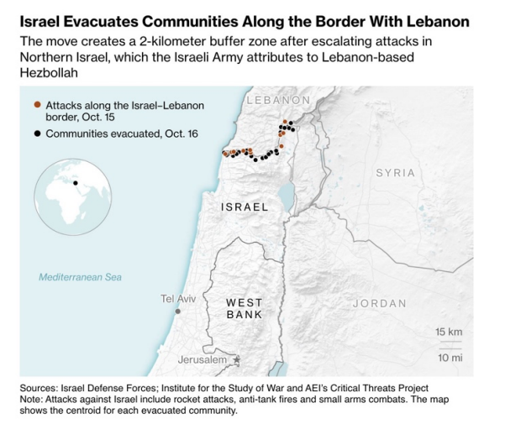
Source: Bloomberg
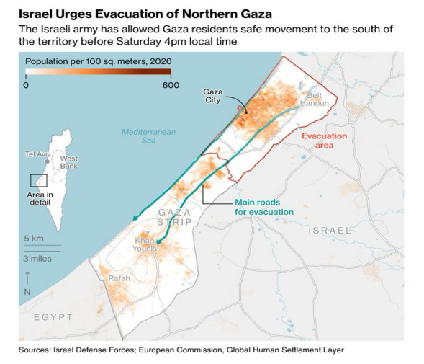
Source: Bloomberg

